Joe Lombardo
Governor
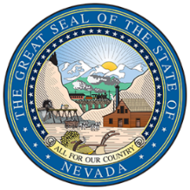
Department of
Health and Human Services
Director’s Office
Helping people. It’s who we are and what we do.
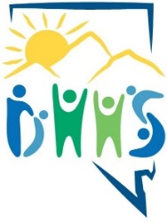

Richard Whitley, MS
Director
MEDIA RELEASE CONSENT: ONE HEALTH
YOUTH INFORMATION:

Full Name: ___________________________________________ Age: ____________

PARENT/LEGAL GUARDIAN INFORMATION:

Name: ___________________________________________________________________________________ Mailing Address: ___________________________________________________________________________
Email Address: _____________________________________________________________________________
Phone Number: (________) - ________ - _________

CERTIFICATION AND PERMISSION TO PARTICIPATE:

I attest that the accompanied artwork/design is the work of my child, ________________________________.
[Print child’s full name]

I certify that the artwork submitted is my child’s original creation. I give permission for him or her to participate in the 2023 Nevada One Health Art Logo Contest. I hereby grant full permission to the Nevada Department of Health & Human Services, and their divisions and affiliates (the “Contest Entities”) to use any photographs, videotapes, website images, recordings, or any other record of this event. I agree that information above is accurate to the best of my knowledge and may be used to send me additional information about the Nevada Department of Health & Human Services programs. I understand that all youth must complete the entire registration form to be eligible to participate in this contest.

I have carefully read the Nevada One Health Art Logo Contest Official Rules* and fully understand and agree to all contest rules and guidelines. Students who do not complete all components will not be considered a participant of the contest.

Parent or Legal Guardian Signature: _______________________________________ Date: ___________

